Amani and Peter Help their Community

Amani was the pastor of a large church in a town in Bingola. It had been about a year since he first heard about a new disease that was killing people in China. As time went on, he heard that more and more people were dying of this disease called Covid. But it didn't seem to be affecting life in his town. Amani and his wife Rose had a son, Mark, who was studying in the capital city. One night as they chatted with Mark, he told them that people were dying there in the capital of Covid, but the Government hadn’t yet issued a public statement.

After a couple months more, no-one could deny that Covid was in the country. People were dying in the big cities and the hospitals were becoming overwhelmed. Oxygen which was needed by the sickest patients, was in short supply. Amani learned a lot about the disease and helped his church people to learn to do the things that would stop the disease spreading, like washing their hands frequently, wearing a mask outside the house, and not getting too close to people. They also learned how to know someone had caught Covid, and to keep away from crowds. Amani worked hard with the other churches in the area, particularly the other large Catholic church in town, which was just down the road. They helped people who had to stay home get food.

Amani and his family listened to the news and were very happy when they heard that some scientists had developed several vaccines against this horrible disease. People in other countries were starting to get them. Finally, they heard the good news that their own country had managed to buy some vaccine and had also been given some vaccine from a central fund. It was a happy day when the President announced that they would begin vaccinating everyone over 70 years and those who were working in hospitals or clinics. 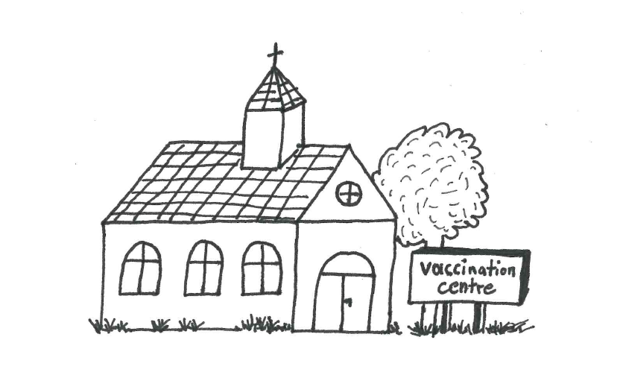
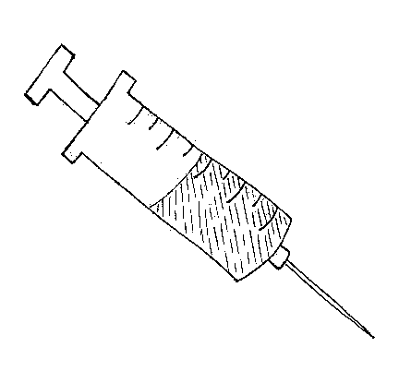
Amani expected everyone to be delighted, but he soon found out that wasn't true. The local Government had asked if the 2 largest churches in town could be used to give the vaccine. This meant his church and the Catholic church down the road. Both agreed willingly, but soon found this wasn't as simple as they thought! First, one of Amani's deacons came around to the house, looking very cross. "Why are you letting our church be used to give the vaccine?" he asked crossly. "I’ve heard that this is a plot of the West to put computer chips in us so that they will control us." Amani patiently explained that this was a vaccine just like the measles or polio vaccine and no-one could get a chip through the needle. The deacon left not sure what to believe.

The next day the team arrived from the capital and set up ready to vaccinate the first people. Amani's father had received an invitation to get a vaccine, but he came round to see his son looking very worried. "I've read about this vaccine," he said. They developed it in just a year. They say normally it takes many years to develop vaccines. How do I know it is safe? Maybe it will make me very ill!" Amani explained that it had been tested on thousands of people and proved to be very safe. He said, "It was done quickly because they had many scientists working on it, and large sums of money went into the research. Please go and get the vaccine, Dad! I don't want you to get sick and die!" Finally, his dad went and had the vaccine.

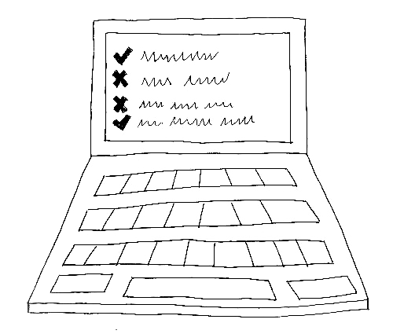
Peter, the priest at the other large church, and Amani would meet every two weeks or so to discuss any problems they needed to deal with together. This time they sat outside a little apart, both wearing masks as they discussed how the vaccine team was getting on. Amani told Peter about his problems with some people who didn't want the vaccine. "Well, I've been told some amazing stories," said Peter. “One of my members told me no-one should get the vaccine because it would give you the mark of Satan! I asked him why he thought that, and he showed me some weird post on the internet that said this. I had to try to convince him that not everything you find on the internet is true! I showed him some other impossible things on the internet, like people saying the earth is flat, and now he understands that you cannot believe everything you read online!”

As time went on, people started to have trust in the vaccine. The team gave the first vaccine to most of the older people and hospital workers in the town. Everyone was told as well that they would need a second injection in three weeks before they would have all the resistance possible to the disease. After that they started vaccinating younger people.

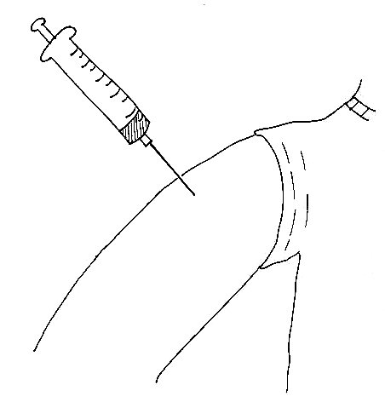
Some of the people who had received the first vaccine, complained a bit that they had sore arms and didn't feel well for a couple of days. However, most people decided that a sore arm was better than dying! So Amani and Peter’s efforts brought blessing to their whole community.

